Simple Monopoly Game User manual

Contents

**1. Introduction** 3

**2. User interface** 4

**3. Game Rule** 8

**4. Special square** 8

**5. End game** 12

MONOPOLY

# **1. Introduction**

The game is played with a board divided into 20 squares, as shown in Figure 1, and a pair of

four-sided (tetrahedral) dice and it can accommodate two to six players.

Besides playing the game, Players can save and load a game.

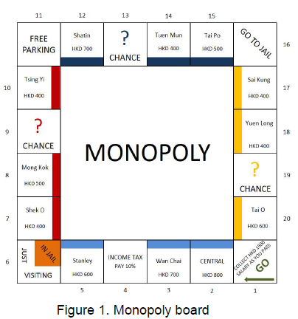

# **2. User interface**

Welcome page

After compile the program, a user menu shows to the user to choose the options in the program.

Programs allow user to choose by input the number (String). (0) to quit the game; (1) to create new game; (2) load game; (3) to read the user manual.

If user input the number is not (0),(1),(2),(3), error has been detected and user need to input again.

Option in user menu:

1. Create new game

Input the number of players: 2 - 6 (integer):

Input the player’s name, starting from player 1

Now we have player1 Ben, player2 Sam, and player3 Peter

The program will default player1 to start rolling the dice first

If user input the number is not 2-6, error has been detected and user need to input again.

The game will end if there is only one player left or after 100 rounds. The winner is the player with the most money at the end of the game. Ties (multiple winners) are possible.

1. Load game

If user has played the game and save the document (i.e., save.txt) before. User can input 2 to start the remaining game.

If the document has been broken, the loading function cannot be started:

1. User manual

If user want to know how to play the game, they can input 3 to open the user manual which is load from document (i.e., userManual.txt). After showing the user manual, it will return to user menu page(i.e., welcome page).

# **3. Game Rule**

* Each player starts with HKD 1500 and no property.
* Players have money and can own properties.
* All players start from the first square (“Go”).
* Players take turns in rolling the dice (default player1 start first) and advancing their respective tokens clockwise on the board. After reaching square 20, moves to square 1 again.
* A round consists of all players taking their turns once.
* After finishing each player turn, saving function will save the game information automatically.
* If after taking a turn a player has a negative amount of money, she retires from the game. All her properties become unowned.
* The game will end if there is only one player left or after 100 rounds. The winner is the player with the most money at the end of the game. Ties (multiple winners) are possible.

# **4. Special square**

Certain squares take effect on a player (see below) when her token passes or lands on the square.

**Property squares (marked by a colored stripe):** They contain the name and the price of the property and can be owned by players. If a player lands on an unowned property, she can choose to buy it for the written price or do nothing (Figure 2). If a player lands on a property owned by another player, she has to pay rent (rent amounts are listed in Table 1).

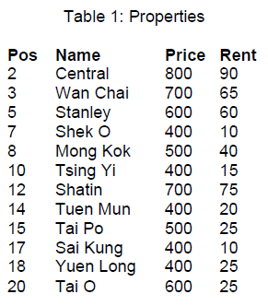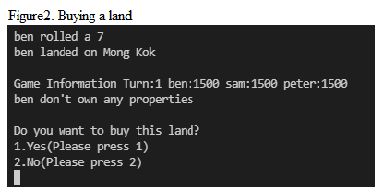

**Go:** Every time a player passes through (not necessarily lands on) this square will get HKD 1500 salary and a information has been shown to notice player.

**Chance**: If a player lands on one of these squares, will gain a random amount (multiple of 10) up to HKD 200 or lose a random amount (multiple of 10) up to HKD 300.

Player land on chance

**Income tax:** If a player lands on this square needs to pay 10% of the money (rounded down to a multiple of 10) as tax.

**Free parking:** This square has no effect. A message has been shown to the player.

**Go to Jail:** If a player lands on this square, she immediately goes to the “In Jail” part of the “In Jail/Just Visiting” square.

**In Jail/Just Visiting:** If a player lands on this square, she is “Just Visiting”: the square has no effect. A information has been shown.

If the player got here by landing on “Go to Jail”, she is in jail and cannot make a move. A player gets out of jail by… (1) paying a fine of HKD 150 before rolling the dice on either of the next two turns; (2) throwing both dice coming out the same face up on any of her next three turns, if player the succeeds in doing this, immediately moves forward by the number of spaces shown by the doubles throw

If the player does not throw doubles by their third turn, she must pay the HKD 150 fine to get out of jail and immediately move forward the number of spaces shown by her throw.

Players choose to pay $150 to escape from jail

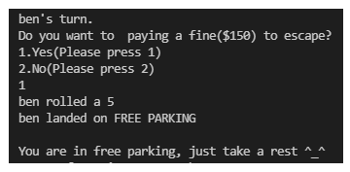

Players choose not to pay and the dice value are not same.

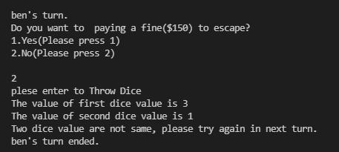

Players choose not to pay and the dice value are the same.

Players choose not to pay and the dice value are not same in 3 times.

# **5.** **End game**

There are 2 situations to end the game. (1) Only 1 player is a survivor in this game (other got bankrupt). (2)100 turns have been finished. A message to list the winner of this game and return to the user menu.

1. Only 1 player is a survivor in this game

1. 100 turns have been finished

